**HR Analytics Dashboard**

**PROBLEM STATEMENT**

HR Analytics helps us with interpreting organizational data. It finds out the people-related trends in the data and helps the HR Department take the appropriate steps to keep the organization running smoothly and profitably. Attrition in a corporate setup is one of the complex challenges that the people managers and the HRs personnel have to deal with.

This project is built on Tableau.

The Dataset consists of the following columns:

Attrition, Business Travel, CF_age band, CF_Attrition Label, Department, Education Field, Emp No(Staff Num), Employee Number(ID), Gender, Job Role, Marital Status, Overtime, Over 18, Training Times Last Year, Age, Daily rate, Distance from home, Education, Employee Count, Satisfaction, Hourly Rate, Job Involvement, Job Level, Job Satisfaction, Monthly Income, Number of companies worked, Percent Salary Hike, Performance rating, Relationship satisfaction, standard hours, stock option level, Total working hours, work-life balance, Years at company, Years in current role, Years since last promotion, Years with curr manager.

The analysis is done on major factors.

### VISUALIZATION AND INSIGHTS:

*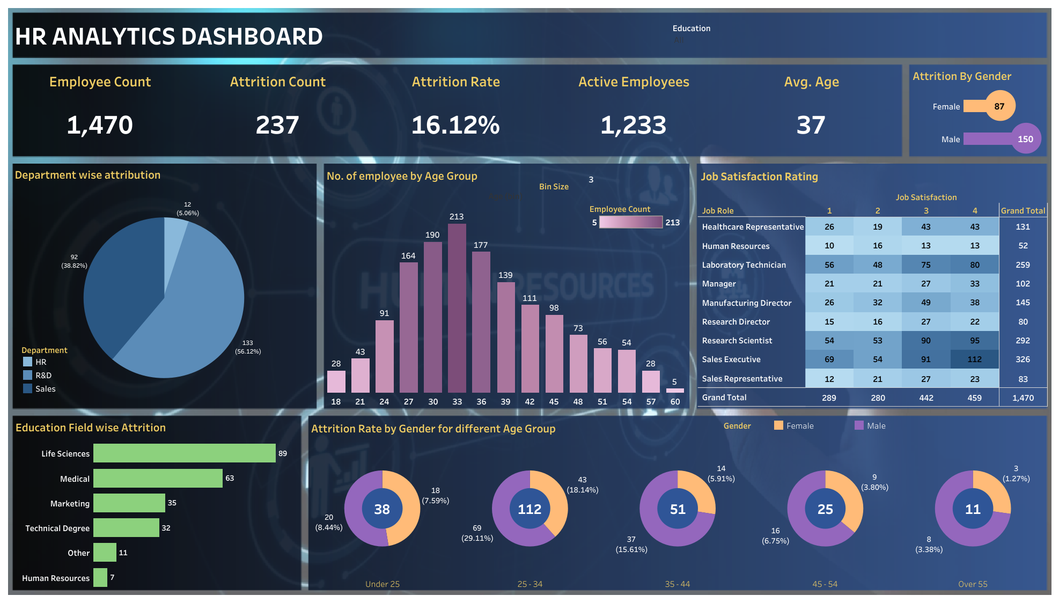Dashboard*

**Important Insights:**

* The total number of Employees present was 1470 and found a 16.12% attrition rate (237 employees left). Thus Active employees were 1233.
* Out of 237 employees who left the organization, 133 employees were from Research & Development Department which is the highest among all departments followed by sales and HR.
* The highest attrition rate was shown by Life Science from Education Domain at 89.
* Highest attrition i.e. 29.11% was made by Male employees from the age group of 25-34 years.
* Talking about Job Satisfaction Rating, Healthcare Representative has the highest grand total of 131.